UNIT 2 SPEAKING
- Look at the photo. where do you think it is? What kind of language is it? How do we use pictures when we write now?
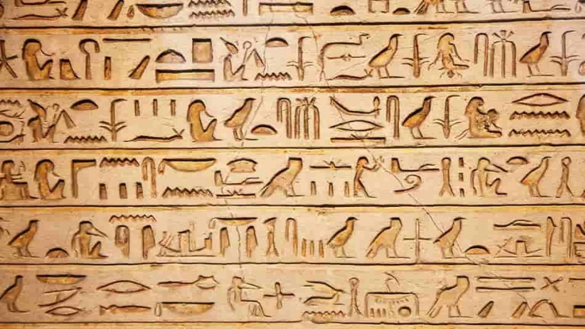
- Read the quote. Does learning English teach you anything about your language?
Those who know nothing of foreign languages know nothing of their own language. Johann Wolfgang von Goethe
- Are people in your country enthusiastic about learning a foreign language? Why / Why not?
- Are there benefits to learning a foreign language beyond the purely practical ones?
- Has learning a language improved your life?
- Do you want people to correct all your mistakes when you speak English? Why / Why not?
- Do you know anyone who has married someone of another nationality? Do they have children? What languages do they all speak?
- What do you think are the pros and cons of bringing up a famiky in a different country?
+ | -

